1. **Bài 1:**

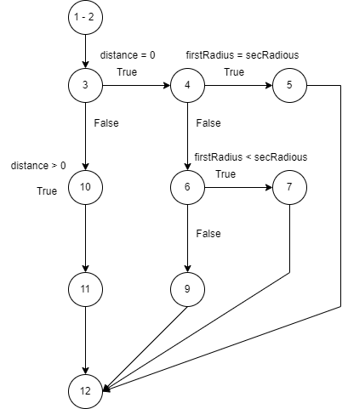

|  |  |
| --- | --- |
|  |  |
|  |  |
|  |  |
|  |  |
|  |  |

1. **Bài 2:**

1. **Bài 3:**

1. **Bài 4:**

1. **Bài 5:**

1. **Bài 6:**

1. **Bài 7:**

1. **Bài 8:**

1. **Bài 9:**

1. **Bài 10:**

1. **Bài 11:**

1. **Bài 12:**

1. **Bài 13**

1. **Bài 14**

1. **Bài 15**

1. **Bài 16**

1. **Bài 17**

1. **Bài 18**

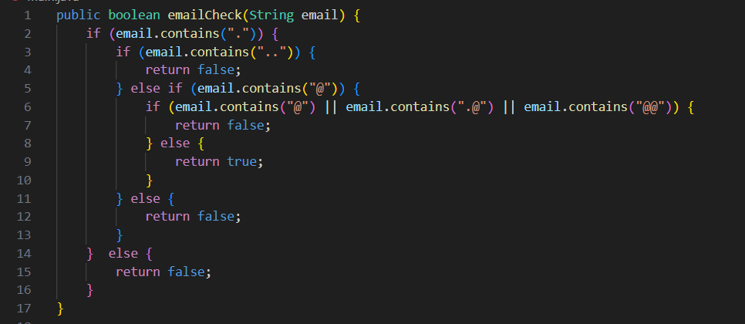

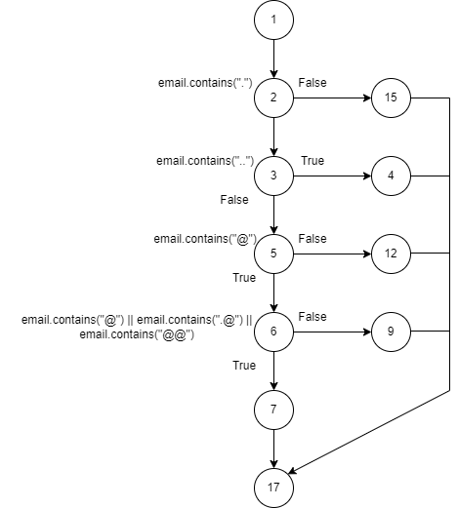

1. **Bài 19**

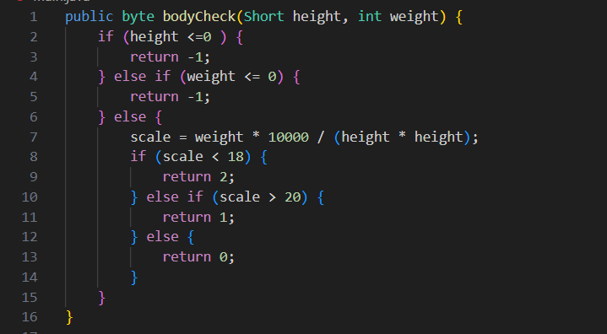

1. **Bài 20**

